A Guided Interview to Your Biography

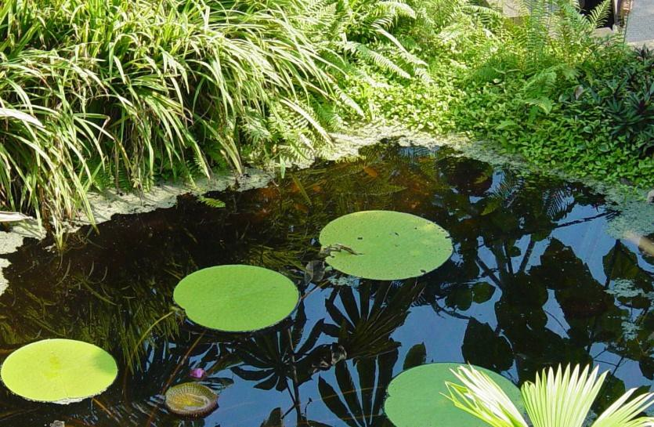

VIP & Lifetime Biography
(562) 719-7192
Based on the book, Your Story: A Guided Interview Through Your Personal and Family History by Inc. Seattle Aero (Compiler)

Instructions
Welcome to VIP & Lifetime Biography, the best way to record your life story and share it with others. Here’s how it works:
- Respond to questions: Read the following questions, slowly, then, gather any important information and write it down in the booklet or on a note pad. Also write down the key memory prompts that will help you recall the facts during the interviews.
Remember, this is your opportunity to record the events of your life you would like others to know. Choose the topics you would like to discuss. You do not have to answer every question or complete every section.
- Collect as many as 20 photos and other materials: Provide copies of your photos and other materials to the biographer.
- Participate in two fifty-minute video interviews: The biographer will ask you questions about your life and its highlights.
- Review and revise: The biographer will produce your video biography on a personal and secure family website. If you wish to have the interviews transcribed or a book written, additional services can be obtained on request.

Many people want to record their life story but cannot "get to it." If this is you or a friend, we can help. Please call today.

Liz Crow
562-719-7192
elsiecrow@gmail.com
vipbiography.com

Table of Contents
Table of Pictures 4
Personal and Family History 5
You 5
Father 5
Mother 5
Brothers and Sisters 5
Grandparents 5
Coming to America 5
Growing-up 6
Day to Day 6
Religion 6
Living Places 6
School Years 6
Military Service 7
Earning a Living 7
Love and Romance 8
Children 8
Living 9
Event Map 10
Standard Pedigree Tree 11
Your Ancestors 11
Your Descendants 13

Table of Pictures
Picture 1:

Picture 2:

Picture 3:

Picture 4:

Picture 5:

Picture 6:

Picture 7:

Picture 8:

Picture 9:

Picture 10:

Picture 11:

Picture 12:

Picture 13:

Picture 14:

Picture 15:

Picture 16:

Picture 17:

Picture 18:

Picture 19:

Picture 20:

4

You

Personal and Family History

What is your full name? If this is not your given or maiden name, what was your birth name? Do you know how and why your name was changed? What is your current address? When and where were you born? Is there a story about your birth that your family would tell?

Father
When and where was your father born? Did he or his family come to America, and if he did, why? Where did they settle, and why? What have you been told about his family and childhood that was important to you? Describe your father as a young person, and as an adult. Who was he? How many sisters and brothers were in his family, what were their full names, and when were they born?

Mother
When and where was your mother born? Did she or her family come to America, and if she did, why? Where did they settle, and why? What have you been told about her family and childhood that was important to you? Describe your mother as a young person, and as an adult. Who was she? How many sisters and brothers were in her family, what were their full names, and when were they born?

Brothers and Sisters
How many children were in your family? What are their full names and birthdates?
What is each brother and sister like?

Grandparents
When and where were your grandparents born? What have you been told about their lives when they were young and when they became adults? Is there a story your mother or father would tell that illustrates what it was like to be raised by their parents?
What memories do you have of your grandparents from when you were growing up? Are any of your grandparents still alive, and how often do you see them? Do you have a favorite grandparent, and what made your relationship special?

Coming to America
What country and town, if you know, did each person on your family tree come from, and when did they come to America, if they did? Did your family keep in touch with anyone in the “old country”? If so, what are their names, address and relationship to the family? Is there any ritual, pastime or preference in your family today that clearly has its roots in your family’s past?

Day to Day

Growing-up

What was it like growing up in your family? Who provided the income in your family, what did they do for a living, and how well off was your family? Was there more than one language spoken in your parent’s home, or in your home?
What did you do in the afternoons after school? Did you have any hobbies? What did you do in the evenings and how would you spend your weekends when you were growing up?
Did you play a musical instrument? What kind of music would your parents listen to; what would you listen to if you were by yourself?
What sort of magazines and books did your family like to read? Did you have a pet? Is there a story you or your family would tell about it? How much did it cost to go to the movies, and what stars and films were your favorites?
How and where did you spend your summers as a child? If your family took a vacation, where would they go, how would they get there, and what did they do?
Did anyone outside your immediate family live with you while your were growing up, such as aunts, uncles, cousins or grandparents?

Religion
What religion were your parents? What were you taught as a child? Do you practice an organized religion and what part does religion or spirituality have in your life?

Living Places
Living Places
How many places did you live while you were growing up, where were they and which is your hometown? What was it like? Describe your house there, including its address, size, modern conveniences, and surroundings. Did you have your own room? What do you remember about your neighborhood and neighbors?

School Years
Do you remember your first day of school or your first school teacher? Did you like school? What were your favorite subjects, and why? Did you play on any sports teams or belong to extracurricular clubs?
During your school years did you look to anyone for guidance and advice, and how did that person affect your life? What did you do the summer after your high school graduation? What were your plans for the rest of your life?

If you went to college, how old were you as a freshman, what college did you attend, and why did you pick that institution? When did you first declare a major? Did you graduate and, if so, in what year and with what degree? If you did not graduate, how far did you get and why did you stop?
After graduation, what field did you enter, and why? Do you feel that you tool full advantage of what college had to offer you?

Military Service
If you served in the military, why did you join the service? During what years did you serve, and to what branch were you attached? Where did you receive basic training? Where were you first posted, and why? What was your serial number and initial rank?
What assignment did you like most and how long were you posted there? Did you see combat during your tour of duty, and, if so, where and in what war of military action? Were you ever injured during combat? What were your injuries, and where were they first treated? Did you return to the war?
Were you a prisoner of war? If so, where were you incarcerated, and for how long? If you were decorated during your tour of duty, for what were you cited? What is your most vivid memory of your service years? If you did not make it a career, why did you decide to leave the military and what was your final rank?

Earning a Living
Did you have any after school or summer jobs when you were growing up? What sort of work ethic or expectations did your parents pass on to you? What was your first fulltime job, how did you get it, and how long did it last?
How old were you when you left home to live on your own? Where did you live, and what did it cost? List all the jobs you have held in your life, with as many dates as you remember.
Have you ever gone into business for yourself? How did your venture turn out? When and how did you settle on a permanent career, if you did? Is there another career that you wish you had pursued instead of the path you chose?
If you are already retired, how has retirement changed your life? Were these the kinds of changes you expected?

Love and Romance
Who was your first real girl/ boyfriend, and how did the relationship develop?
If you are married, how many people did you date before you met your spouse? Where did you meet and what attracted you to each other? How long did you date before you became engaged? What did your families think about it?
Where did you live before you got married? When and where did you marry? What was your wedding like? Where did you spend your honeymoon? Where was the first place you lived as a married couple? Describe the early years of your marriage? Are you still married to the same person?
If you are not married to the same person, how and why did the marriage end? Are you still friends. Did you marry again? If so, when, and how has it worked out?

Children
Did you and your spouse discuss whether or not you wanted to have a family, and, if so, what issues came up during that discussion? If have children, when did the first baby come? How many children did you have in all?
Are any of your children adopted? If so, why did you choose to adopt?
What is the full name and date of birth of each of your children? Where do they live? If they have finished their schooling, where do they work and at what job? How often do you see your children?
What have you enjoyed about being a parent? What did you find most challenging? If you had it to do over again, what would you change about the way you parented your children? What story do you like to tell about each of your children when they were small?
What was the best piece of advice you ever gave your children? What values did you strive to teach your children when they were growing up? What about each of your children makes you most proud?
Did you take an active role in your children’s schooling, or in community affairs, and in what ways? Did you travel as a family? Where did you go for vacations? Did other members of your family live with you? If so, who, and did they help take care of the children?
If your children are grown, how did your life change when they moved out of the house? Are any of your children married, and, if so, who are they married? When did they get married? Do you have any grandchildren? If so, what is the full name and date of birth for each of your children’s children?

What do you enjoy about being a grandparent? What do you find most challenging? Have you become a great-grandparent? If so, what is the full name and date of birth for each child, and which of your grandchildren is the parent?
What advice would you give your children and grandchildren?

Living
If you belong to a religion, has your faith helped you during the difficult periods of your life? What do you believe happens to people after they die? What do you think each of us owes to the less fortunate of the world? What have you done to help others, and do you feel it is enough?
When you judge yourself in your own mind, is there a person against whom you measure yourself?
What makes life worth living for you, in other words, why do you bother getting up in the morning? And how has your answer to that question changed over the years? What are the most important rules you have made for yourself to cope with the tragedies and adversities of life?
Has your life turned out the way you thought it would when you were young? Is there an incident or insight that changed you and permanently altered your future? What was it that happened, and how did it affect you?
If you had your life to live over again, what, if anything, would your change? What is the best piece of advice you were ever given, and the best advice you ever passed along yourself? Looking back at your life, of what are you most proud?
When did you first vote for a president, who were the candidates and what was important to you in making your decision? Over the years, have you belonged to a political party, and if so, what positions and policies drew you to that party? Describe the world events that were most important in your VIP & Lifetime Biography.
What historical events and technologies do you feel most changed the world during your VIP & Lifetime Biography, and what were their effects?
How important to you is your leisure time, and how do you spend it? What do you do for exercise and how often do you do it? Do you have a pet, if so, what is its name and what need does it fill in your life? Do you have a vacation home or a favorite place you like to get away, and what need does it serve? Describe how you live today and how close it is to your ideals of the way you would like to live.
What do you think holds the greatest promise for the future of the planet, and the gravest danger?

Event Map

Date | Event | Description

Standard Pedigree Tree
Your name Born Where
Brothers and sisters names, birthdates and places

Married
Who Where When
Brothers and sisters names, birthdates and places

Your Ancestors Father’s name Born
Where
Brothers and sisters names, birthdates and places Married
Who Where When
Brothers and sisters names, birthdates and places

Mother’s maiden name Born
Where
Brothers and sisters names, birthdates and places

Your Paternal Grandfather

Born Where Died Where
Brothers and sisters names, birthdates and places Married
Who Where When
Brothers and sisters names, birthdates and places

Your Paternal Grandmother Born
Where Died Where
Brothers and sisters names, birthdates and places

Your Maternal Grandfather Born
Where Died Where
Brothers and sisters names, birthdates and places

Married
Who Where When

Brothers and sisters names, birthdates and places

Your Maternal Grandmother Born
Where Died Where
Brothers and sisters names, birthdates and places

Your Descendants
Child’s name Born
Where Married
Who Where When
Grandchild’s name Born
Where Married
Who Where When

