The Biography of
Kenneth Fisher
2005

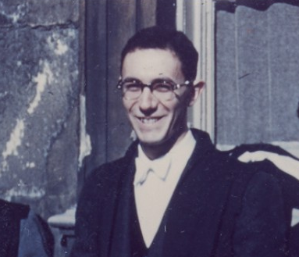

Lifetime Biography
Copyright 2005 all rights reserved
(800) 458-2464

Table of Contents

Personal and Family History 5
Family Life 9
School Years 11
Earning a Living 17
Love & Romance 19
Alisa 21
Children 23
Family Tree 28

Personal and Family History

Dr. Henry Kenneth Fisher
Ken Fisher was born as Henry Kenneth Fischlowitz on May 23, 1933. He was named Henry after his paternal grandfather who had previously died. His mother agreed to this name; however she refused to call him that while he was growing up. Instead, she insisted on calling him Ken, which is what he still goes by today. His last name was changed from Fischlowitz to Fisher in 1935 when his father changed his last name for business purposes.
Ken’s father had been very popular in High School as one of the best football players. This was an advantage when he met people and talked with them about insurance, but the name Fischlowitz was difficult for secretaries to relay to their bosses when Ken would call on them. Instead of saying, “Mr. Fischlowitz is here to see you,” secretaries would often say, “there is a man here to see you.” This had a completely different affect and sometimes Ken’s father would be turned away because of it.

Father, Harry Fischlowitz
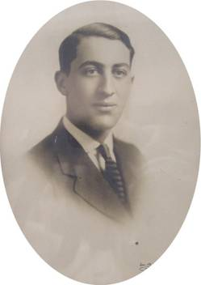
Ken’s father was born and raised in St. Louis, Missouri. He was raised in a part of the city that was a bit gritty and tough and he was often picked on because he was the child of immigrant parents. However, he became a well known football star in their town. He is the youngest of three brothers, one who lived in Texas and the other in Oklahoma. In 1921 he went to Antwerp to visit relatives in the diamond business.
At the time of Ken’s birth, his father was a life insurance salesman. He was also a member of a social club called the “Comet Club.” Members of the club visited often and even purchased property together. The Comet Club played a significant role in the lives of Ken’s parents, and his mother even after Ken’s father passed away.

Mother, Besse Albert
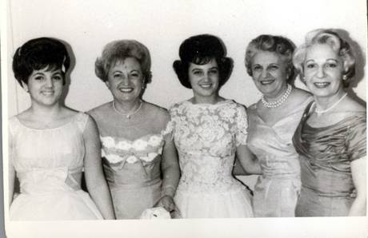
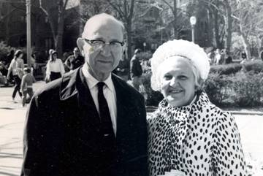
Ken’s mother was a very unselfish person. She always put other’s needs above her own. When she became pregnant with Ken, she gave up a job as a secretary to the Board of Jewish Education in St. Louis. She is the oldest of three sisters. She was born and raised in St. Louis, Missouri. Like Ken’s father, she also grew up in part of the city that was tough. However, she was a beautiful girl and was chased by boys throughout high school. She was the football dance queen and Ken’s father was a football hero, although they were several years apart in school, this was the forerunner of a very good match!

Sister, Elaine

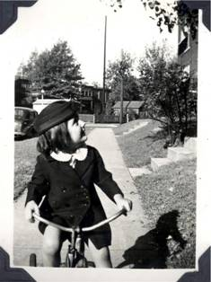
Ken has one younger sister, Elaine, who was born three years after Ken. Elaine was also the football dance queen in high school, like her mother. Ken and Elaine have remained close.

Maternal Grandparents, Ely Albert and Rebecca Zeid

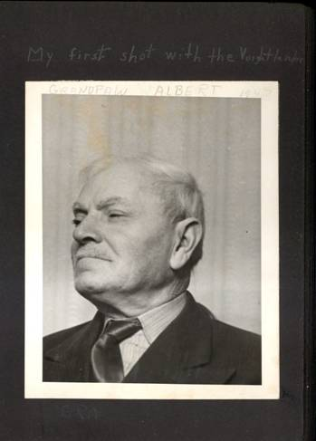
Ken’s maternal grandparents immigrated to the United States from Ukraine where his maternal grandfather went to school through the third grade. When his family could not afford shoes for him, he quit school to go to work and help the family. He served in the Russian army under Czar Nicholas III for five years as a blacksmith. After he was released from the army once, he was drafted a second time. Instead of rejoining, he walked 1,500 miles to Germany and sailed to the United States where he had relatives in St. Louis.

St. Louis was one of the fasted growing cities in the world, and the fastest growing city in the United States. After arriving in America, he worked for a few years, and then returned to the Ukraine to get his fiancé. They moved to the United States and did well financially. Sometime between 1908 and 1910, his grandmother asked his grandfather to `look outside the window and tell her what he saw. He said, ‘a car’ and she asked, “Do you know whose it is?” He said, no, and she told him it was his! There is no doubt who handled the finances in their family.

Paternal Grandparents, Heinrich and Bertha Fischlowitz
Ken’s paternal grandparents were from Krakow, Poland. Ken’s paternal family appears to trace back to a man named Fischl from the fifteenth century. This man got a medical degree from the University of Padua in 1508, which was the only medical school in Europe which would accept Jews at the time.

Family Life
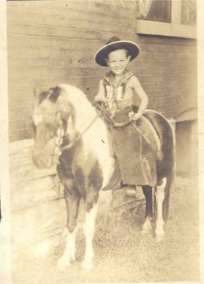
Growing up, Ken’s family always lived in an apartment. He has an early memory sitting on a pony at the apartment they lived in on Pershing Street in St. Louis. The second apartment Ken lived in was on Waterman Street. This apartment was on the ground level and had a big, beautiful porch out front. There were water drains on each side of this porch and one day his sister put his toy soldiers down this drain thinking they would come out the other end. They did not and all the soldiers were lost! Sweetly, about sixty years later his sister gave him a set of toy soldiers as a commemoration gift for those that she had lost down the drain.
Ken remembers waking up one morning in September of 1939 while it was still cold and dark outside. He could hear the newsboy outside announcing that Hitler had invaded Poland. At this time, Ken knew that Germany was bad and the US was good, but he did not understand the severity of the War. He also did not realize that he had relatives living in Poland when this occurred. He would follow what was happening in the newspaper and made a scrapbook, but in his child’s mind it seemed like a game, it was not personal to him.

After leaving this apartment, his family moved to an apartment at 722 Kingsland, in the suburb of University City. This apartment was right across the street from the elementary school and the junior high school. The apartment was at the location where children from the elementary school were let across the street by the crossing guard. There were many children in this neighborhood, and Ken still has occasional contact with some of them now.
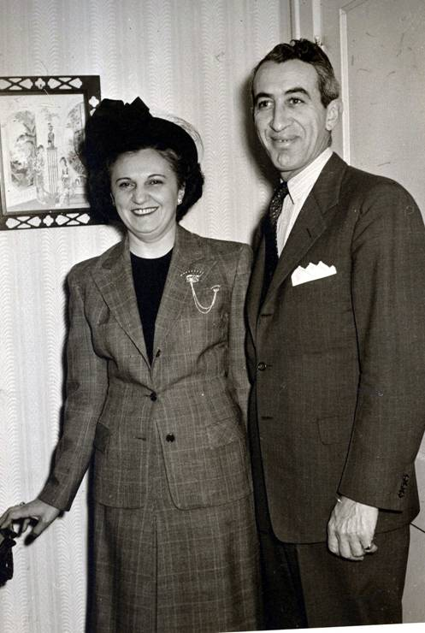

School Years

Grade School and High School
Ken always loved school. His first teacher was named Mrs. White and Ken remembers that his favorite thing about her class was playing with the blocks. He did not stay in Mrs. White’s class very long because they had to move to a bigger apartment when his sister was born. Ken’s family moved to University City which had a highly acclaimed school district. The University City high school was one of the top twenty high schools in the country. The student population was half Jewish.
While in school Ken did not have a favorite subject, he enjoyed all of them. Recently, one of his long time school mates became one of his patients, and this man teased Ken by telling him that he had been jealous of him during their school years because Ken was the only guy in their class who received more valentines than him.
The high school Ken attended in University City was very academic and a large percentage of the students went on to college. During high school he was on the college preparatory track. Ken was involved in many activities while in high school including being the photographer for the school newspaper and a co-editor of the yearbook. For a period of time he was the class president and he graduated as the vice president of his class. Though he was not very athletic, Ken was very popular and had many friends.

College and Graduate School
Though Ken was the first in his immediate family to go to college, he always knew that he would go. He was initially interested in twenty colleges; however he completed applications to only three: Washington University, Harvard University, and Carlton College. He received a large scholarship to Carlton College located in Northfield, Minnesota. This was a very good school and has since the highest percentage of national merit scholarship recipients. A high percent of students there also went on to graduate school. There are also large alumni contributions made to this school.
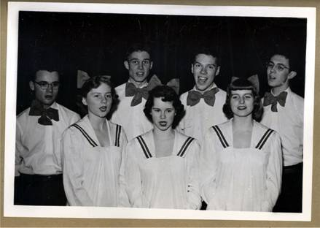
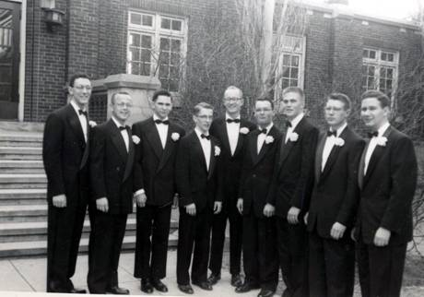
Ken flourished while attending Carlton College. For a period of time he was first in his class during his freshman year. He had many opportunities while at this school and participated in many activities such as yearbook and the school newspaper. He was also the president of his graduating class. Ken was very social and had many friends.
He dated frequently, however nothing serious resulted from this. He had been dating a girl for awhile when his father died during this emotionally turbulent time Ken and ended the relationship with her. There were approximately 1,000 students at that school and it was mandatory for all students to live on campus. His graduating class had 125 students. Currently 1,800-2,000 students attend Carlton College.
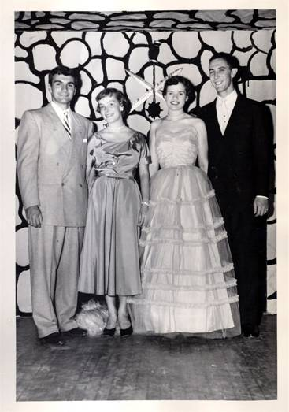
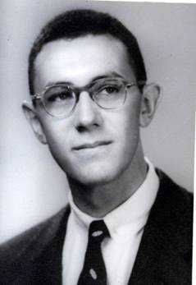
When entering Carlton College, Ken had his four year curriculum plan laid out, however he was undecided if he wanted to be a doctor or the Secretary of State. When he met with his pre-med counselor, his idea of Secretary of State was demolished because the counselor was very strongly opposed to Ken being a government student. Ken experienced no prejudice while attending Carlton College, and there was also no separation by social class. The school was organized as a social cooperative and all the students paid a set fee at the beginning of the year and were able to attend all activities and events throughout the year at no additional cost.
After graduating from Carlton College, Ken was still unsure of what he wanted to do, so he utilized the placement service offered by this school. He met with Leith Shackle, the director of placement and explained to her his situation. He was still unsure if he wanted to go to medical school, however he was considering going into radiology because there was much money to be made in that field. When Ken met with the placement director, he raised the possibility that he should attend graduate school in chemistry first. The director suggested that he go to school in Europe. Ken pursued this and applied for both the Marshall and Rhodes Scholarships.
The Marshall Scholarship interview was first and was intended to be very uncomfortable. The interview was conducted with him sitting in the middle of a circle surrounded by fifteen interviewers. Ken recognized this strategy and decided that he would not play along. Instead of turning to face the person who was asking a question, Ken faced the same direction throughout the entire interview.
The interview for the Rhodes scholarship was more traditional and comfortable. There were eight interviewers sitting at a table facing him. One of the interviewers was a doctor from the Mayo Clinic and did not ask Ken a single question throughout the entire interview! Ken passed this initial stage and went to the regional interview in Des Moines, Iowa where they would announce the winner. All the contestants would line up and the winners were announced. When Ken heard his named called, his initial reaction was, “Do I really want to do this?” Ken is still friends with the other candidates who also won the Rhodes scholarship that year.
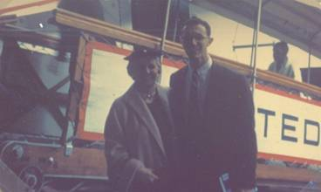
After winning this scholarship, Ken still had to apply and be accepted into a college Oxford University. He applied and was accepted by Queen’s College. He told his mother this by phone and she had a mixed reaction. On one hand she was very excited for her son, yet on the other she knew that she would miss him terribly while he was away.
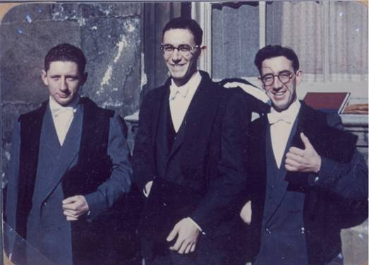
It was Ken’s goal while attending Oxford to decide if he would go onto medical school or not. After much consideration, he decided to go into business and applied at Harvard Business School and MIT. He was accepted by both schools and decided to attend the MIT Graduate School of Industrial Administration.
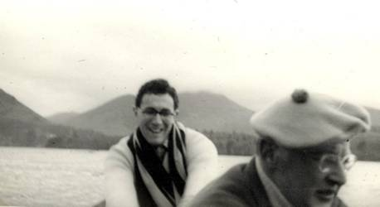
Ken attended MIT for one year and received a job working for the Bell Telephone System because this related to his thesis project. However, the aircraft recession of that time domino-ed and Bell cancelled his job position. After a three week search, Ken found another summer job.
Ken began working as a research technician for the brain biochemistry lab Washington University. At this point, he decided that he wanted to attend medical school. Ken’s supervisor was on the admissions committee of the Washington University Medical School and he proposed Ken be admitted for the upcoming fall. The class size was even enlarged by one in order to admit him!
Ken received the Jackson Johnson Scholarship which was the largest scholarship available. However, after the first year his grades were not as good and he was unable to retain the scholarship for the following years. Ken found out that one reason his grades were not as good as they could have been was because he had poor vision which made it very hard to read. Luckily, the problem was identified and Ken graduated from medical school near the top of his class four years later.
When it was time for him to begin his internship, he did so at Barnes hospital, which was the hospital affiliated with Washington University Medical School. This was among the best hospital in the country. He continued there for a year of internship and a year of his residency work then he became interested in chest medicine and decided to move on.
He had an interview with Cornell University; however the interviewer never showed up for the interview. Ken stayed in New York with a former roommate and was persuaded to interview for Albert Einstein Hospital. He was very pleased. The interviewer was fun and bright and Ken was excited about the possibilities at this hospital. He received a job there and moved to New York for a two year program. The Bronx Municipal Hospital was also considered to be one of the nation’s best, and it had an excellent clinical training program. While he was in the program, he took three months and rotated through pathology, cardiology and chest radiology in order to experience other fields of medicine closely related to chest diseases.

Earning a Living
The summer after Ken’s freshman year in high school he started his first job as a shipping clerk at the Edison Brother’s Shoe Company. This was not a good job as his supervisor was degrading and would frequently tell him that he was stupid. However, Ken moved up with this company and became a retail salesman for another branch of the same company. Later, Ken had a job working in the personnel department of the Universal Match Company where he photographed employees for security. After this he became a chemistry technician with the same company.
Throughout college and graduate school Ken held multiple jobs in the business field. After MIT, he received an offer to work for McDonnell Aircraft as the personal assistant to James McDonnell on the condition that he would not move to back Boston. Ken refused the job because he wanted to finish his MIT degree. Instead he got a job working as a research technician for the department of brain biochemistry at Washington University Medical School.
Ken did his internship and a year of residency at Barnes Hospital. He then decided that he was interested in chest medicine and moved onto Albert Einstein Hospital in New York to complete a two year training program there. After this program was complete, his boss Henry Williams got Ken a job as post-doctoral fellowship for research in cardiopulmonary disease at the University of California, San Francisco in 1966.
Ken and Barbara moved to San Francisco, and Ken continued there for four years. This was a very good experience for Ken as the Cardio Vascular Research Institute was very advanced. There were 75 post doctoral fellows working there from all around the world. Ken became a Fellow himself at age 37. Those who worked at this school were very bright and social and would often get together outside of work on the weekends.
Ken eventually moved to Tucson, Arizona. While in Tucson, Ken worked for the University of Arizona Pulmonary Dept. at the V.A. Hospital. In 1976 Ken moved from Tucson, Arizona to Los Angeles, California. He took one technician with him and together they packed up and moved his entire laboratory. He moved for two reasons: one was because he was unhappy in his marriage and wanted time away to see if he wanted to remain in the marriage or move on. Barbara threatened divorce if Ken left, so he moved to Los Angeles for work reasons and it also allowed him the time away he desired.
Ken was appointed to the UCLA Medical faculty. The West Los Angeles V.A. Hospital was probably the best V.A. Hospital in the country. He became full time chief of the pulmonary department in the hospital. He also did clinical research. This kept him very busy and research moved very slowly. He continued doing this for five years but was unhappy with the way things were going.
Between 1979 and 1980, Ken started covering for several colleagues in their private practices. While doing this he tried to remain chief on a part time basis and continue to teach post doctoral trainees in lung disease. However, the private practice schedule he was keeping made this nearly impossible and he resigned from the V.A. Hospital in 1981 and went into private practice on a full time basis.

Love & Romance
Ken met his first wife on a bit of a fluke. He had gone to New York to meet with another girl. After spending a weekend together, she had to return to school for exams. Earlier, Ken had promised a friend from Washington University that he would go out with a girl named Barbara if he got the chance, so he called her and they met. They immediately hit it off and went on a long trip together the next summer. They were engaged a year later. Ken was attracted to Barbara because she was bright and confident. She was in law school and very involved with liberal causes which he was also interested in. They both loved camping and she was also an excellent cook.
Barbara was from a town called Hibbing in Northern Minnesota. Her family was Jewish and did not approve of any of her previous boyfriends because they had not been Jewish. In fact, they would not let her attend Carlton College because her non-Jewish boyfriend was going to attend there. Barbara was attracted to the fact that Ken was a Jewish doctor who had attended Carlton College. Ken and Barbara were married in 1964 at the Annabelle Taylor Chapel in Cornell University. Ken’s sister lived nearby and the service was excellent and as Ken remembers with a smile “reasonably priced.” Ken’s friend who had originally urged Ken to call Barbara played the organ for the ceremony, and the Rabbi who performed the ceremony was a long time friend of Ken’s who ended up later marrying Barbara’s cousin.
After they were married, they lived at 2952 Williamsbridge Road, Bronx, New York. They lived in the upstairs of a two story home. The family that lived downstairs was very nice. The man was a carpenter from Macy’s. He and his wife had two children and were very kind and hospitable toward Ken and Barbara. This place was also close to Albert Einstein Hospital which made Ken’s commute very easy.

Alisa

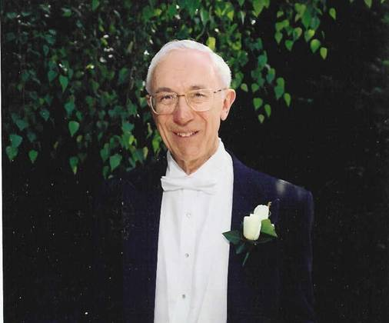

Ken (Groom)
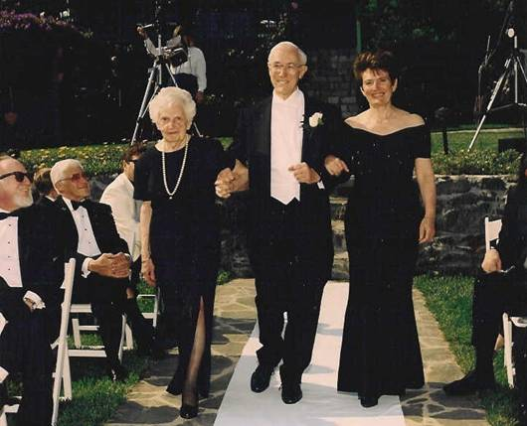

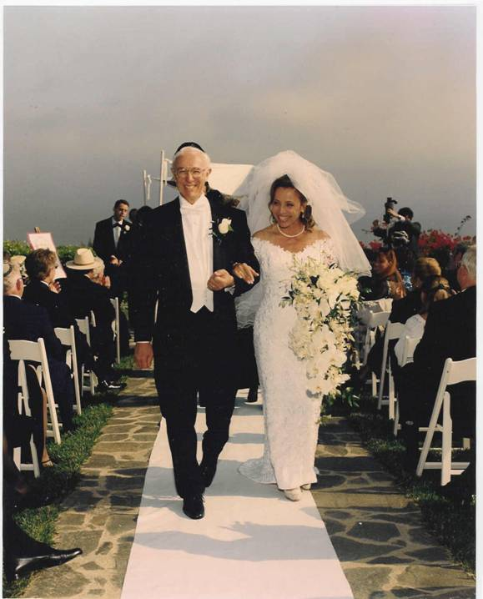

We did it!

Children
After getting married, Barbara wanted to have children as soon as possible and Ken did not. However, Barbara was able to convince Ken and in December 1965 their first child, Hugh, was born. When Hugh was six months old, they moved to San Francisco for Ken’s work.
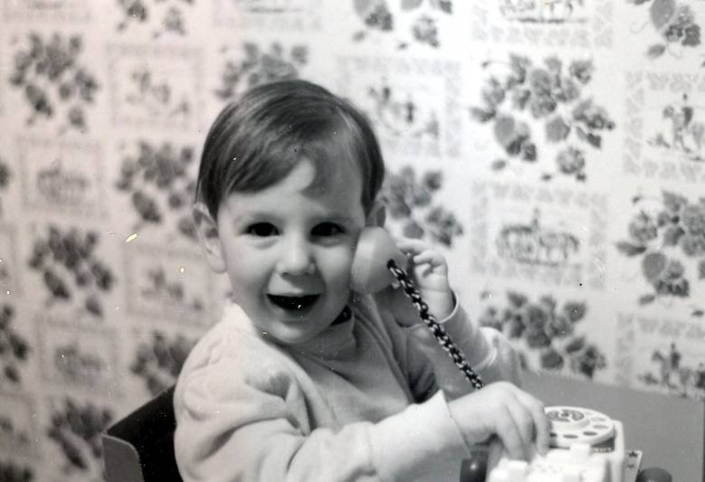

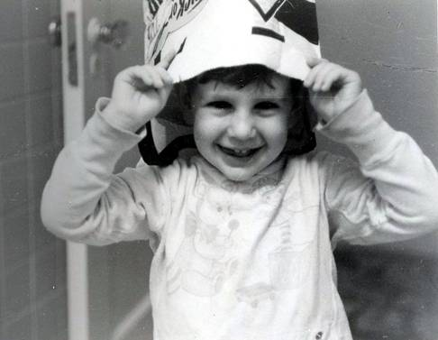
Their second child, Joshua, was born in February of 1967- just 13 months after Hugh. Their third child, Michael was also born in San Francisco in May of 1968.
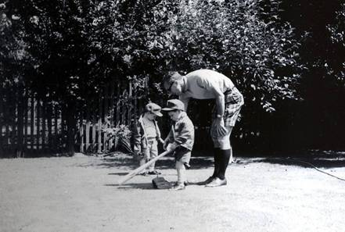
Having children was a blessing for both Ken and Barbara; however they had different ideas about parenting. They had previously decided that when the children were born Barbara would stay home and take care of them. However, after they were born she did not want to stop practicing law and this brought some contention between her and Ken.
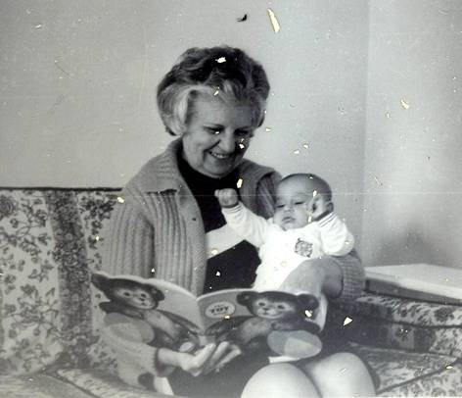
Ken loves being a parent. He remembers when his three children were still in diapers the family would go on many Sierra Club camping trips and load up the car full of diapers. This was a necessity, especially since they would be in the mountains for ten to twelve days without access to a store to buy more.
One of the best things for Ken when his children were young was coming home to play with them. He saw a resemblance of himself in each of his children and this was very heart warming. Hugh was very science minded and he and Ken would always work on science projects together. Hugh would eat up all the information his father would give him, he loved to learn. This was exciting for Ken since he is very into the science field himself.
Joshua was not as interested in science, however he and Ken spent many quality hours playing together with other things. Michael was very musical from a very young age. All three of the children played the guitar, and Josh and Michael were also very good singers. Ken would often give all three boys a bath at the same time and he would play the guitar and they would all sing together. This was a very precious time for all of them.
When Ken moved from Tucson to Los Angeles in 1976 and had to leave the children with Barbara in Tucson, he asked each of them what special thing he could do with them before he left. Moving away from his children at this time was one of the hardest things Ken has had to do in his life. Hugh was eleven and wanted a tree house, so he and Ken built one together. Josh wanted to go camping, and he and Ken went to the top of Mount Lemon and stayed there a few nights. Mike asked Ken to take him to the Suzuki Music School in Los Angeles so that he could learn to play the cello. Ken did this and stayed a week with Mike in Los Angeles. Mike was very good at the cello, and when he was going back home, his teacher made Ken promise that if Mike ever moved to Los Angeles he would enroll in the school and she would be his teacher.
Currently, Hugh is in his final stages of finishing a Ph.D. program in molecular biology at Rutgers University. His thesis is 487 pages long and has revolutionized the understanding of the green fluorescent protein which occurs naturally in sea creatures and is used to signal chemical reactions in living cells. They do this by emitting light at wavelengths after absorbing it at other wavelengths. These proteins are used in pharmaceuticals and biochemical research. Hugh’s thesis has demolished previous theories about this protein.
Joshua is a lawyer. He had a very successful law school career at Colombia. After that he worked for the law firm that defended Bill Clinton. He also worked as a contract lawyer for the Discovery Channel. Currently he works for Cisco Systems as in-house counsel.
Michael lives in Scottsdale, Arizona. He pursued the music career and for awhile he was a member and co-founder of a fairly successful industrial rock band. The band was even featured on “The Crow” movie soundtrack. However, that band broke up and now Michael does music independently and released a record a year ago. Michael also works as an internet consultant. He founded a company called Machines of Loving Grace.
Later he started a company which created and maintained websites for large music companies such as Atlantic Records. He sold this company to US Web which was the largest web page manufacturer in the country. He became an expert in usability testing for US Web. He continues to do this because it also allows him to have a music career.
Ken also has three step children from his marriage to Alisa: Ian, Shelly, and Audi. Ian is a computer engineer and lives in San Diego, California. He is very creative and develops hardware and software to carry out various commercial tasks. Ian was able to create a receiver so that each radio station could receive commercial ads by satellite, to be aired the next day from the parent company. Ian founded this company with two of his friends from the University of California, San Diego. The company merged with a larger company in Texas. Ian founded another company and is very successful.
Shelly received her Masters Degree in biochemistry from Boston University. She is married to a man named Ares who is an accountant from Harvard. They currently have four children and live in Israel. They are orthodox Jews. Audi received his Masters Degree in business economics from Southwestern University in Dallas, Texas. He currently works for amazon.com.

Family Tree

Mother’s Family
Descendants of Ely Albert
Generation No. 1

1. ELY¹ ALBERT was born April 01, 1880 in Bar, Ukraine, and died October 1963 in Missouri. He married REBECCA ZEID. She was born 1882 in Ukraine, and died Abt. 1940 in Missouri.

More About ELY ALBERT:
Cause of Death: Stroke
Occupation: Proprietor of scrap iron and metal business in St Louis
Social Security Number: Bef. 1951, 495-32-7905

More About REBECCA ZEID:
Cause of Death: Pancreatic Carcinoma

Children of ELY ALBERT and REBECCA ZEID are:
2. i. BESSE² ALBERT, b. 1911, St Louis, MO; d. Martin's Run, Media, Pennsylvania.
ii. SADIE ALBERT, b. Abt. 1914, St Louis, MO; d. Mc Knight Place, St Louis, Missouri; m. MORRIS LEHRMAN.

More About SADIE ALBERT:
Medical Information: In good health except for deafness. She died quietly in her sleep a few hours before a breakfast date with Ken.

More About MORRIS LEHRMAN:
Occupation: Auto Parts Dealer

3. iii. ALICE ALBERT, b. Abt. 1917, St Louis, MO; d. Abt. 2003, Texas.
iv. MALE ALBERT.

More About MALE ALBERT:
Cause of Death: Strep Throat
Medical Information: died at age 3

Generation No. 2

2. BESSE² ALBERT (ELY¹) was born 1911 in St Louis, MO, and died in Martin's Run, Media, Pennsylvania. She married (1) HARRY E. FISHER, son of HEINRICH FISCHLOWITZ and BERTHA. He was born January 29, 1902 in St Louis, MO, and died 1952 in St Louis, MO. She married (2) SAUL ZEID. He died in age 93.

More About HARRY E. FISHER:
Cause of Death: Metastatic Renal Cell Carcinoma
Occupation: Worked as Life Insurance Salesman/Broker

Children of BESSE ALBERT and HARRY FISHER are:
4. i. HENRY KENNETH³ FISHER, b. May 23, 1933, St Louis, MO.
ii. ELAINE FISHER, b. 1936, St Louis, MO.

3. ALICE² ALBERT (ELY¹) was born Abt. 1917 in St Louis, MO, and died Abt. 2003 in Texas. She married (1) HERMAN YAURITZ. He died Abt. 1945. She married (2) LOUIS SCHUMACHER.

Children of ALICE ALBERT and HERMAN YAURITZ are:
i. RITA³ YAURITZ.
ii. JUDI YAURITZ.

Generation No. 3

4. HENRY KENNETH³ FISHER (BESSE² ALBERT, ELY¹) was born May 23, 1933 in St Louis, MO. He married (1) BARBARA EDELSTEIN 1964 in Annabelle Taylor Chapel in Cornell University. He married (2) ALISA HAIM 1995 in Malibu, CA.

More About ALISA HAIM:
Note: Previous married name Lerner

Children of HENRY FISHER and BARBARA EDELSTEIN are:
i. HUGH EDWARD⁴ FISHER, b. December 1965.
ii. JOSHUA BENJAMIN FISHER, b. January 1967.
iii. MICHAEL BERNARD FISHER, b. May 1968.

Father’s Family
Descendants of Heinrich Fischlowitz
Generation No. 1

1. HEINRICH¹ FISCHLOWITZ was born Abt. 1865 in Krakow Poland/Austria, and died 1929 in St Louis, MO. He married BERTHA. She was born Abt. 1865 in Krakow Poland, and died 1940 in St Louis, MO.

More About HEINRICH FISCHLOWITZ:
Immigration: 1883
Note: 1902, Founder of Zionism in St. Louis, MO
Occupation: Worked as traveling neck tie salesman

More About BERTHA:
Immigration: 1897
Note: Diabetic

Children of HEINRICH FISCHLOWITZ and BERTHA are:
2. i. BEN J² FISHER, b. September 22, 1898, St Louis, MO; d. January 1978, Dallas, Texas.
3. ii. CHARLES FISHER, b. 1901, St Louis, MO; d. Abt. 1960, Tulsa, Oklahoma.
4. iii. HARRY E. FISHER, b. January 29, 1902, St Louis, MO; d. 1952, St Louis, MO.

Generation No. 2

2. BEN J² FISHER (HEINRICH¹ FISCHLOWITZ) was born September 22, 1898 in St Louis, MO, and died January 1978 in Dallas, Texas. He married RUTH. She was born in Texas.

More About BEN J FISHER:
Medical Information: Severe Coronary Artery Disease, Congestive Heart Failure
Occupation: Worked as traveling salesman of men's clothing
Social Security Number: 456-01-5053

Children of BEN FISHER and RUTH are:
i. REBECCA³ FISHER, d. Texas.
ii. HENRYETTA FISHER, d. Texas.
iii. ROSE H FISHER.
iv. DOROTHY FISHER, d. Texas.

3. CHARLES² FISHER (HEINRICH¹ FISCHLOWITZ) was born 1901 in St Louis, MO, and died Abt. 1960 in Tulsa, Oklahoma. He married ELSIE.

Child of CHARLES FISHER and ELSIE is:
i. JACQUELINE³ FISHER.

4. HARRY E.² FISHER (HEINRICH¹ FISCHLOWITZ) was born January 29, 1902 in St Louis, MO, and died 1952 in St Louis, MO. He married BESSE ALBERT, daughter of ELY ALBERT and REBECCA ZEID. She was born 1911 in St Louis, MO, and died in Martin's Run, Media, Pennsylvania.

More About HARRY E. FISHER:
Cause of Death: Metastatic Renal Cell Carcinoma
Occupation: Worked as Life Insurance Salesman/Broker

Children of HARRY FISHER and BESSE ALBERT are:
5. i. HENRY KENNETH³ FISHER, b. May 23, 1933, St Louis, MO.
ii. ELAINE FISHER, b. 1936, St Louis, MO.

Notes

Lifetime Biography
Copyright 2005 all rights reserved
(800) 458-2464

